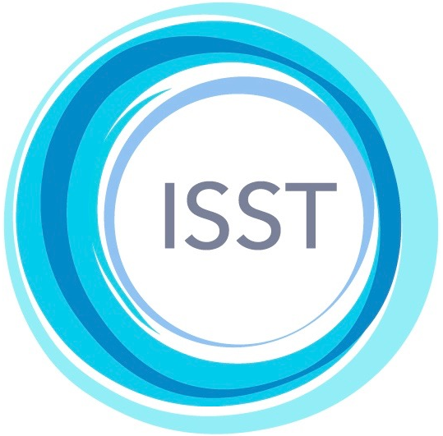
INTERNATIONAL SOCIETY OF SCHEMA THERAPY
ETHICS AND CONFLICT RESOLUTION COMMITTEE FILING A COMPLAINT WITH THE ISST
Approved by the Executive Board 8th September 2020
Please read the guidelines carefully, before you file a complaint with the ISST about the conduct of an ISST member.
Complaints are dealt with by the ISST’s Ethics and Conflict Resolution (ECR) Committee. Please note that in order for the committee to be able to operate a fair and transparent process, complaints cannot be considered that are raised anonymously or where the complainant is not willing for their name to be disclosed to the person against whom the complaint is made.
- Types of complaints we can attend to
- About a therapeutic service provided to you by an ISST member that you consider to have been rendered in a manner that is unethical or not consistent with the principles of schema therapy.
- About an ISST member’s conduct that you consider to be potentially harmful or damaging to yourself or members of the public.
- About an ISST member’s conduct that you consider might cause reputational damage to the ISST.
- Any information about a member that may raise questions as to whether a member should continue as a member of the ISST.
- Unprofessional conduct on the part of an ISST member as defined by the Code of Conduct of the ISST.
- Types of complaints we cannot consider
- Complaints about individuals who were not ISST members at the time of the events or who are not current members.
- Complaints against professional bodies and organizations (we deal only with concerns about individuals).
- Matters of a legal nature, financial disputes, or claims for compensation.
- Matters that should be decided by a court.
- If the individual’s professional body has already conferred a decision about the complaint, their decision must stand. The complaint cannot be presented to ECRC for reconsideration.
- Customer service or consumer issues.
- Making a professional apology.
- If the event took place more than two years ago.
- Any matter presented in the complaint over which ISST and thereby ECRC has no authority.
- How to make a complaint
If your complaint falls within the above specified areas, and you decide to go ahead and formally submit a complaint, please use the Ethics and Conflict Resolution Complaint Form provided and add all the supplementary material that is indicated.
- What happens to a complaint once it is submitted?
The ECR committee will investigate all cases objectively and independently.
A member of the ECR committee will contact the complainant to acknowledge receipt of the complaint form. If the complaint falls outside of accepted parameters, the complainant will be informed, and the case closed.
If the complaint is considered appropriate, the ECR committee will notify the complainant and request additional information if required. They will then inform the member (“the respondent”) that a complaint has been made against them and send them a copy of the complaint. The respondent will be given 30 days in which to respond. Following receipt of materials from the respondent, the Committee will review the response and documents.
In situations where English is not the primary language, all documents that are submitted to the ECR Committee that are not in English will need to be translated into English by an independent translator. The ECR Committee will take steps to ensure that both parties are comfortable with the person designated as the independent translator.
In cases where the ECR Committee has recommended mediation, both parties must be comfortable with the procedures for keeping records of the whole process. If mediation is carried out in a language other than English and both parties would like the ECR Committee to review the mediation, the records will need to be translated into English and both parties must agree with the choice of the independent translator.
The length of time required to resolve a complaint depends on the nature and complexity of the complaint, and on the length of time the complainant and respondent take to respond to queries and deadlines. In many cases, the process of a complaint’s resolution will encompass a period of at least 3-6 months.
Following completion of the investigation, the committee will forward a report of their resolution and/or their recommendations to the Executive Board of the ISST. In cases where the ECR Committee determines that the complaint has been without cause and a violation has not been committed, and the Executive Board concurs with the Committee, the case will be closed.
In some cases, the ECR committee and the Executive Board may determine that, while no ethical or professional violations appear to have occurred, there are concerns about the actions or conduct of the respondent, such that it would be appropriate to advise the respondent of this and provide mentoring or education. In these cases, a member of the ECR committee will engage in correspondence with the member until a satisfactory conclusion is reached and the case closed.
If during the investigation the complaint is found to be of a serious nature (e.g., violence, sexual offense, serious or sustained dishonesty or fraud), the ECR committee may decide to refer the case to the respondent’s professional body for action and may also recommend that the Executive Board suspend his/her membership of the ISST. The period of suspension will allow the member adequate time to clear the issue and/or obtain legal counsel, etc. If the investigation of the member’s professional body concludes the issue to be of a criminal/malpractice nature, ISST membership will be terminated.

